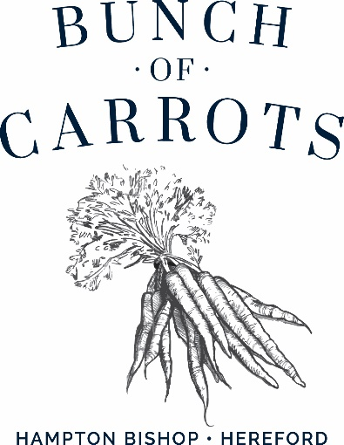

##### To start or something light…

Homemade soup of the day, crusty bread **£6.25**

Chicken Caesar salad with bacon & parmesan **£7.50 / £13.95**

Crisp devilled whitebait, tartare sauce **£7.25**

Chicken liver pate, toasted ciabatta & fruit chutney **£7.25**

Focaccia bread, olive oil, balsamic vinegar **£4.75**

**Mains**

Beer battered fresh fish of the day, chips, peas & tartare sauce **£15.25**

(GF) (VE) Sweet potato, caramelised red onion, mixed seed & nut tart with chips & salad **£14.25**

Traditional steak pie, Wye valley ale, mushrooms, puff pastry, chips & peas **£15.95**

(VE) Plant based burger, brioche bun, chips, coleslaw & salad garnish **£13.95**

Chef`s fruity, medium hot curry of the day, rice, poppadom & mango chutney **£13.95**

Wholetail scampi, chips & peas, tartare sauce **£14.75**

**BUNCH OF CARROTS BISHOP CARVERY**

A choice of succulent Herefordshire meats carved by our chefs with a selection of freshly prepared vegetables

Adult **£17.00** Children ( under 12 ) **£13.50**

** (V)Nut Roast **£17.00**

**\*\* nut roast must be pre ordered at the table**

**More over page…..**

**Our sandwiches served from 12-5pm**

**Choice of white or granary bread**

**Served with crisps & salad leaves**

Mature cheddar cheese & chutney **£7.50**

Prawn, lemon chive mayo **£8.75**

Carved meats from the carvery **£8.50**

**Children`s Menu**

Chicken nuggets ( chicken breast )

Pork sausages

Cod fish fingers

**All above served with chips and peas or Heinz baked beans**

**All at £7.50**

**Side Orders**

House mixed salad **£3.50** (VE) Slaw **£3.75**

Cheesy chips **£4.50** Onion rings **£3.95**

Portion of chips **£4.25**

**Desserts**

Please see our blackboard for a selection of desserts and ice creams

**Coffees**

Cafetiere of coffee **£3.50**

Cappuccino **£3.50**

Latte **£3.50**

Double espresso **£3.25**

Pot of tea **£2.95**

Hot chocolate **£3.75**

Liqueur coffees **from £4.95**

**All prices are inclusive of VAT. Service is at your discretion.**

**(V) – suitable for vegetarians (VE) – suitable for vegans**

**Please speak to our staff before you order your food & drink if you have a food allergy or intolerance.**