**.**

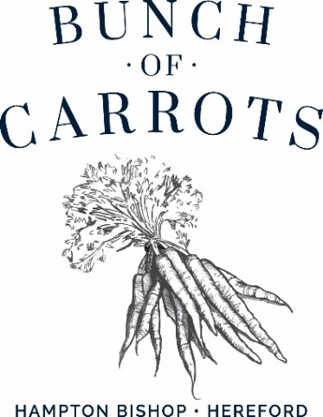

##### To start or something light…

Homemade soup of the day, crusty bread **£7.00**

Chicken Caesar salad with bacon & parmesan **£8.00 / £15.00**

Crisp devilled whitebait, tartare sauce **£8.00**

Chicken liver pate, toasted ciabatta, fruit chutney **£8.00**

Garlic bread **£4.00**

**Mains**

Beer battered fresh fish of the day, chips, peas & tartare sauce **£17.00**

(GF)(VE) Sweet potato, caramelised red onion, mixed seed tart with chips & salad **£16.50**

Traditional steak pie, Wye valley ale, mushrooms, puff pastry, chips & peas **£18.00**

(VE) Plant based burger, brioche bun, chips, coleslaw & salad garnish **£16.00**

Chef`s fruity, medium hot curry of the day, rice, poppadom & mango chutney **£15.50**

Wholetail scampi, chips & peas, tartare sauce **£16.00**

Quiche of the day, chips, salad & slaw **£14.00**

**BUNCH OF CARROTS BISHOP CARVERY**

A choice of succulent Herefordshire meats carved by our chefs with a selection of freshly prepared vegetables

Adult **£18.00** Children ( under 12 ) **£14.00** ** (V)Nut Roast **£18.00**

**\*\* nut roast must be pre ordered at the table**

**More over the page…..**

**Our Sandwiches**

**Served from 12-5pm**

Choice of white or granary bread served with crisps and salad leaves

(Replace crisps for chips £3.00 extra)

Mature cheddar cheese & chutney **£8.00**

Prawn, lemon chive mayo **£9.50**

Carved meats from the carvery **£9.00**

**Children`s Menu**

Chicken nuggets ( chicken breast )

Pork sausages

Cod fish fingers

**All above served with chips and peas or Heinz baked beans**

**All at £9.00**

**Side Orders**

House mixed salad **£4.50** (VE) Slaw **£4.50**

Cheesy chips **£6.00** Onion rings **£5.00**

Portion of chips **£5.00**

**Desserts**

Please see our blackboard for a selection of desserts and ice creams

**Coffees**

Cafetiere of coffee **£3.50**

Cappuccino **£3.50**

Latte **£3.75**

Double espresso **£3.50**

Pot of tea **£3.00**

Hot chocolate **£3.75** Liqueur coffees **£6.00**

**All prices are inclusive of VAT. Service is at your discretion.**

**(V) – suitable for vegetarians (VE) – suitable for vegans**

**Please speak to our staff before you order your food & drink if you have a food allergy or intolerance.**